JMeter Guide
- Download Java https://www.java.com/en/ and run
- Download-https://jmeter.apache.org/download_jmeter.cgi
- Open bin folder
- Find jmeter bat file and run as ADMINISTRATOR

Run Jmeter
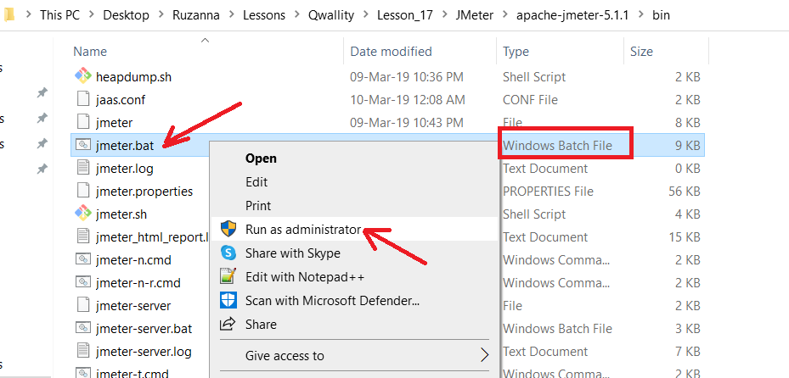
- CMD and Jmeter app should be open. DO NOT close cmd during using JMeter app
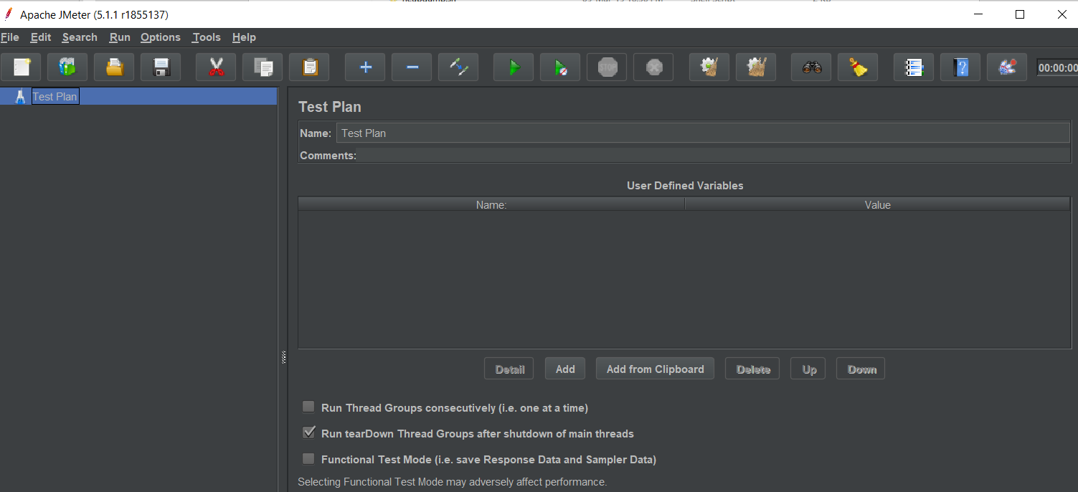
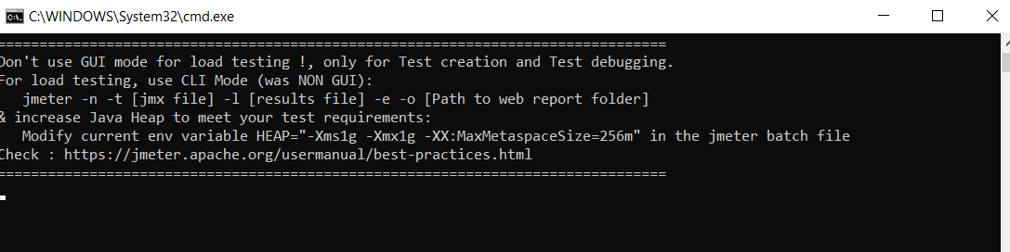

Thread Group
- Select Test Plan (Test Plan =test suit, set of tests like collection in Postman) and add Thread Group (to send request from more than 1 user)
Test Plan->Add->Threads(users)-> Thread Group
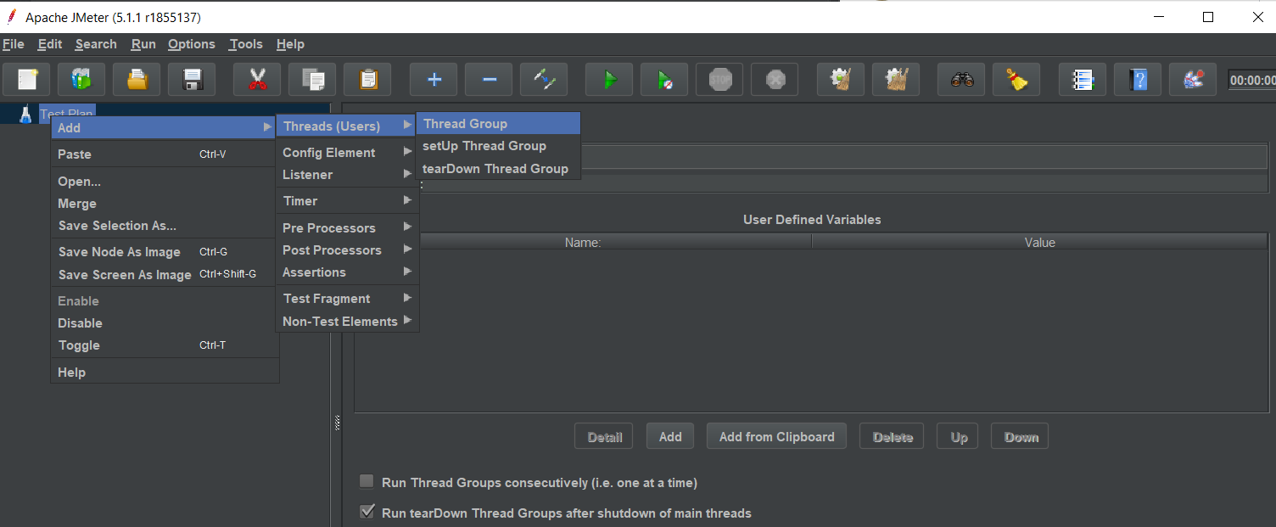
- Thread group is added. 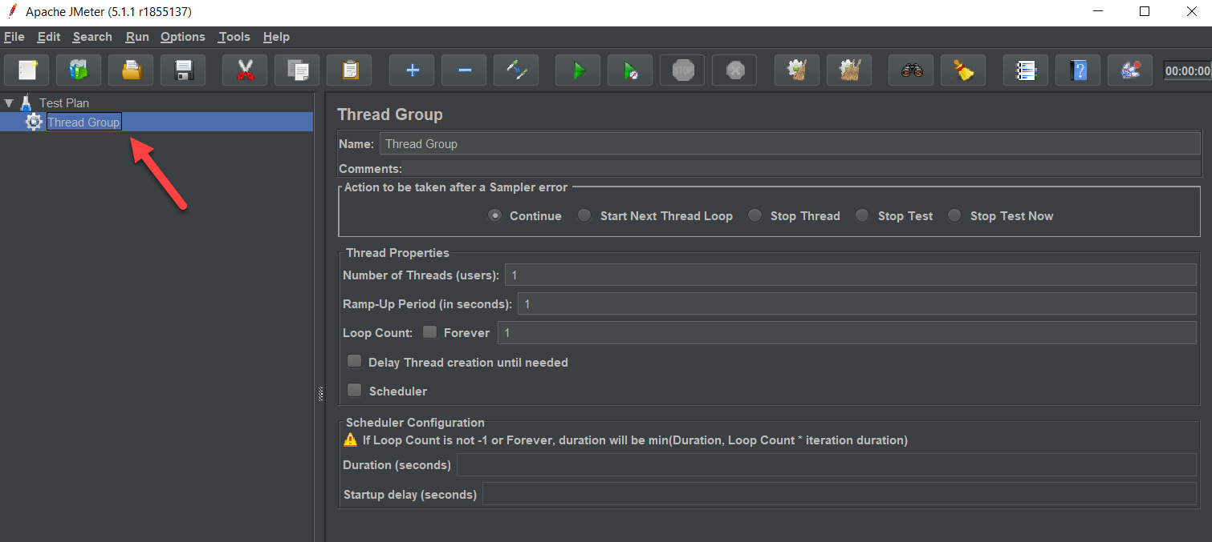

- Add threads count and ramp up period and loop count as much as needed.
Will have 10*2=20 request
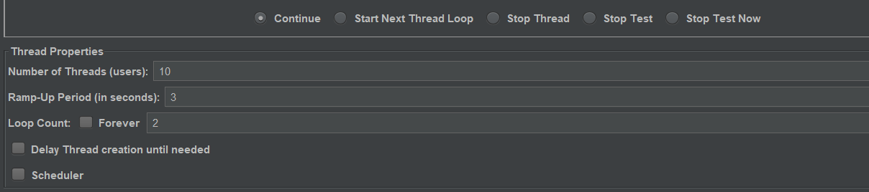
- Rename Thread Groupe name e.g. Thread Group for Google
- Save somewhere in your PC (e.g. Desktop)
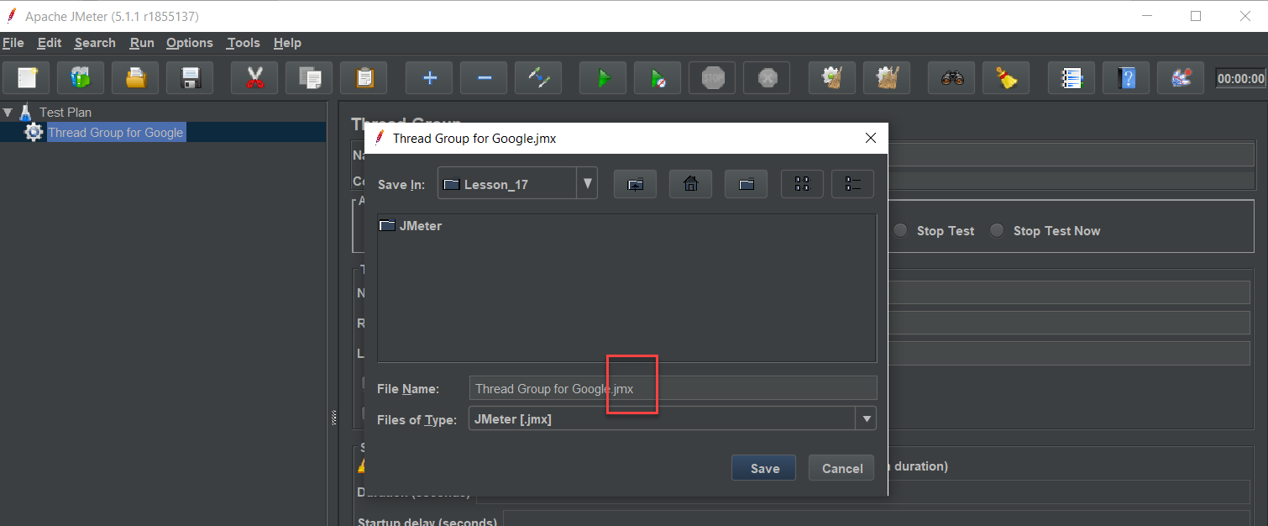
- Thread Properties has 3 main fields
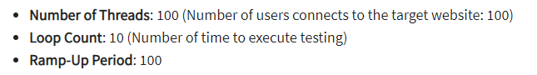
In this example we will have 1000 call=100user *10 loop count(call for each user)
* Ramp-Up Period tells JMeter how long to delay before starting the next user.
We have 100 users and a 100-second Ramp-Up period, then the delay between starting users would be 1 second (100 seconds /100 users)

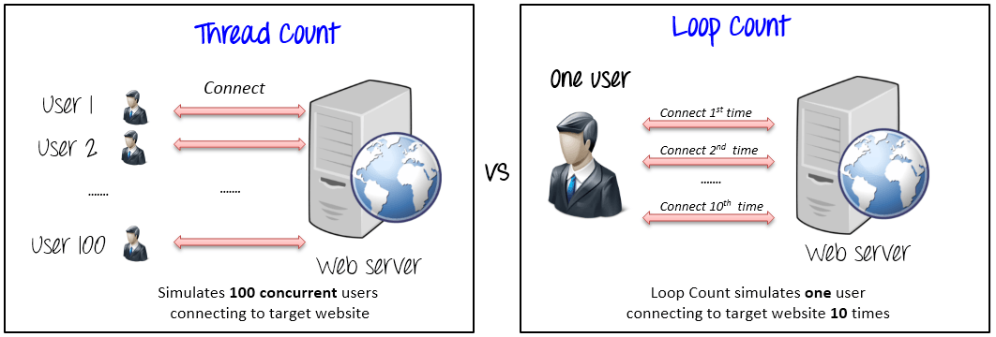

- For example, we want 2 users, loop is 10, Ramp-Up Period=
- Now we need to put request which should be sent (In Jmeter need 2 elements)

HTTP Request Defaults
- Click on created Tread Group->Add->Config Element-> HTTP Request Defaults
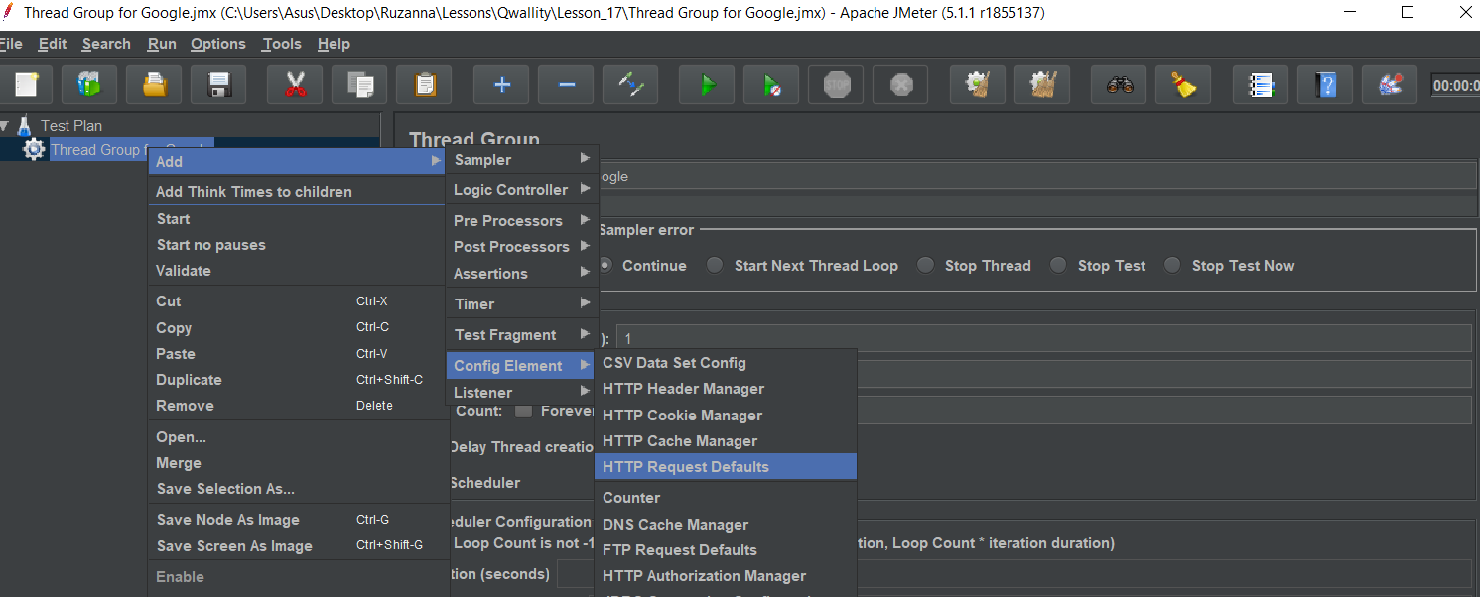
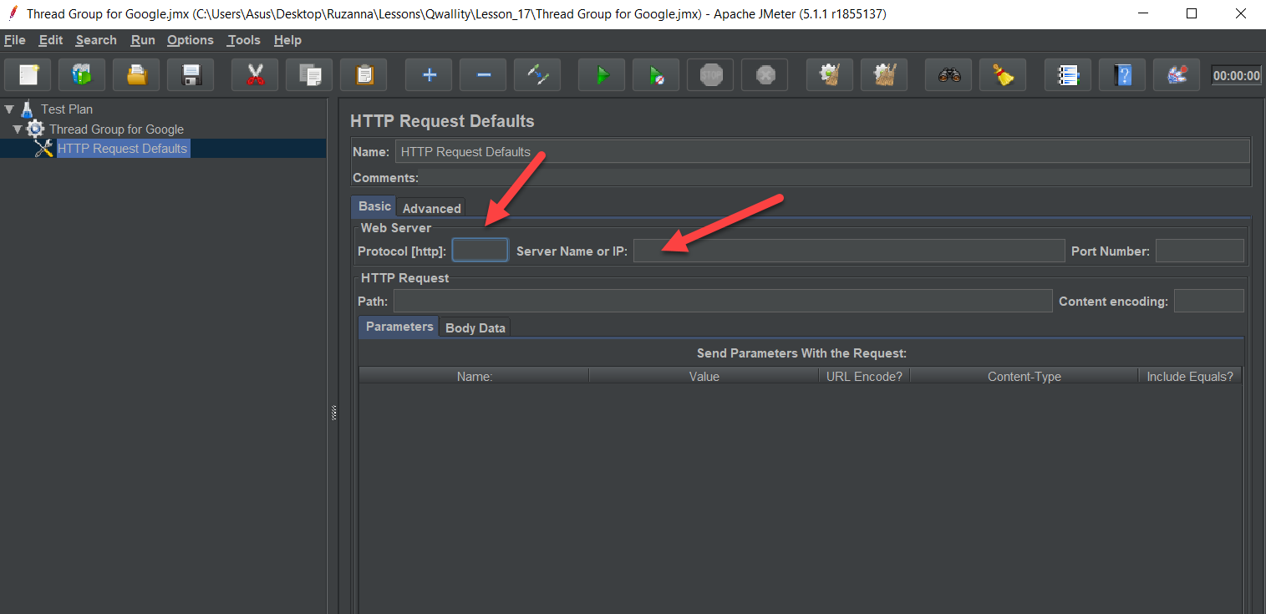
- Enter protocol* (http, https)
* Protocol-In networking, a protocol is a set of rules for formatting and processing data. Network protocols are like a common language for computers. The computers within a network may use vastly different software and hardware; however, the use of protocols enables them to communicate with each other regardless.
- Enter Server Name or IP-e.g. https://www.google.com
*IMPORTANT: Do not put slash at the end of domain like this (https://www.google.com/)
*Host name is a combination of the name of your machine and a domain name (e.g. machinename.domain.com). The purpose of a host name is readability - it's much easier to remember than an IP address. Host name resolves to an IP address by DNS.
Say your name is Steve and your phone number is 555-1212. DNS is the phonebook. I can "call Steve" or I can "call 555-1212" and get the same result. One's a name, one's an address.
The hostname is a mapping to the IP address. Over time the same hostname could map to a different IP address. This might be done where a web service is rebuilt on a different machine for example. In Jim's example, Steve might change his phone number but he would still be Steve.
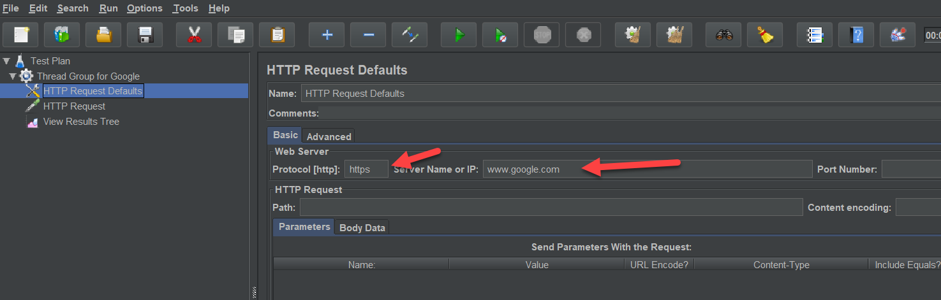

HTTP Request
- Add HTTP request-- Tread Group->Add->Sampler-> HTTP Request
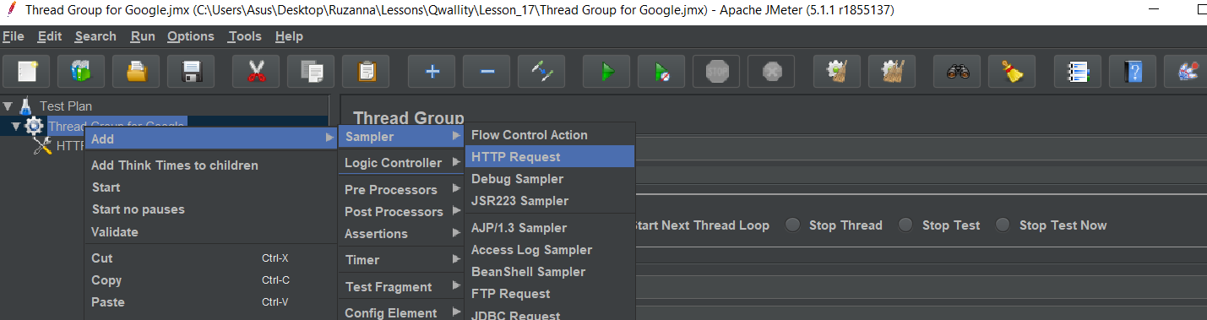
*HTTP Request Default vs HTTP request
HTTP Request Default is main request with domain -https://www.google.com/
HTTP request is full request
Google translate - https://translate.google.com/
News- http://www.google.com/news
Calendar- http://www.google.com/calendar
Image search-https://www.google.com/images
- Add path after main domain without slash (/)- e.g. calendar, news
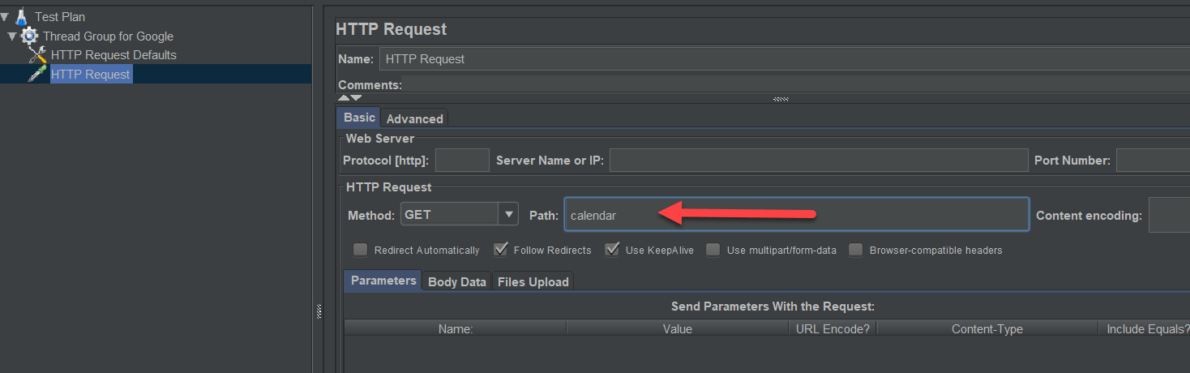
- Save and run
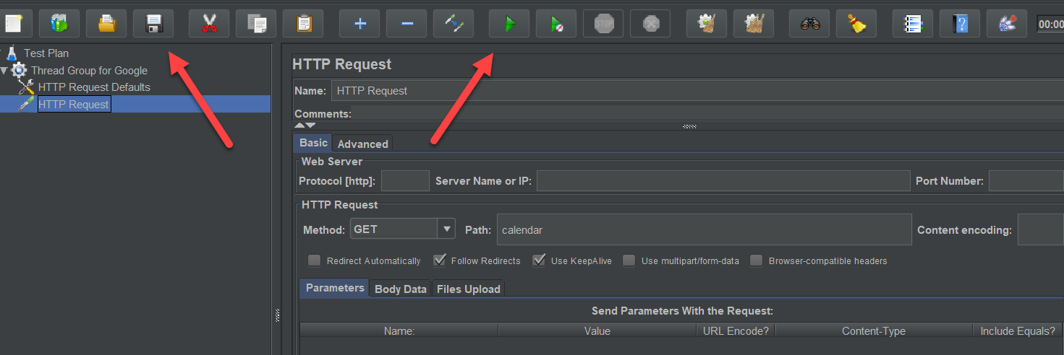
No result is shown!!!

View Results Tree
- Now how we can see the result- Tread Group->Add->Listener-> View Results Tree
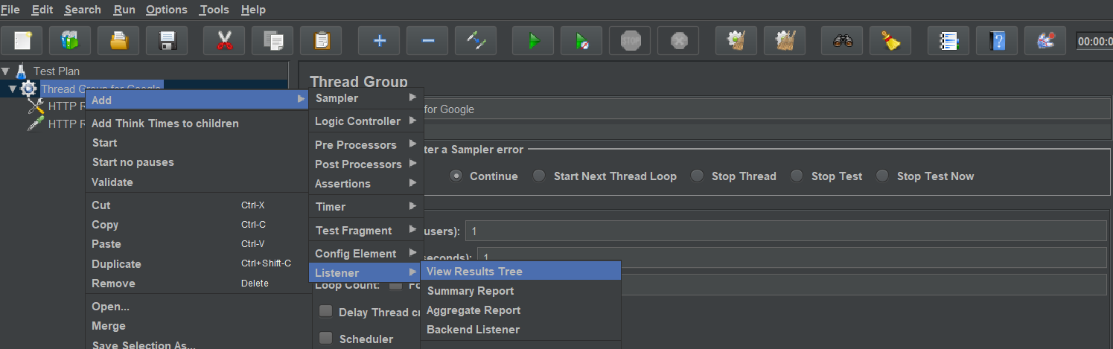

- Click Clear ALL and run again
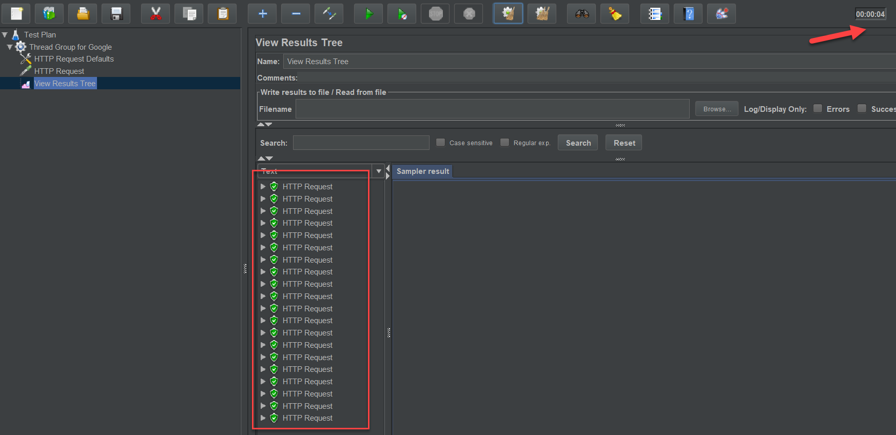
- Click the row to see each request result
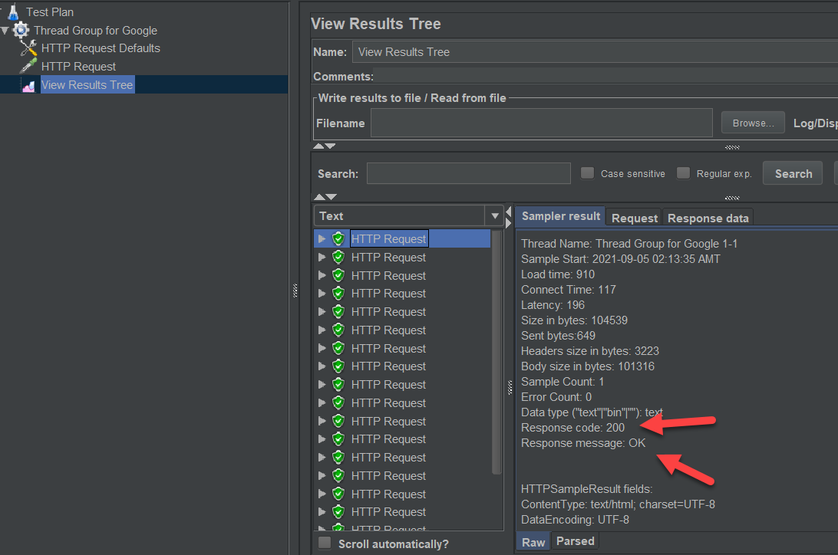
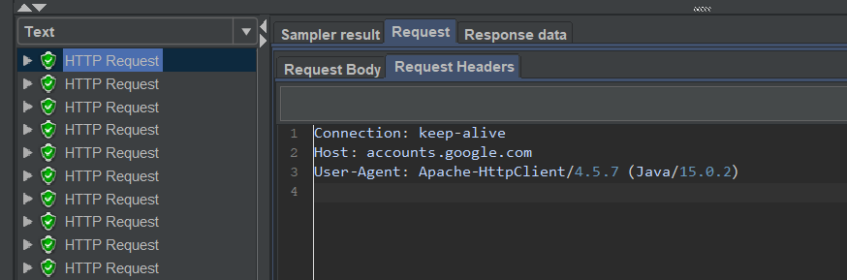
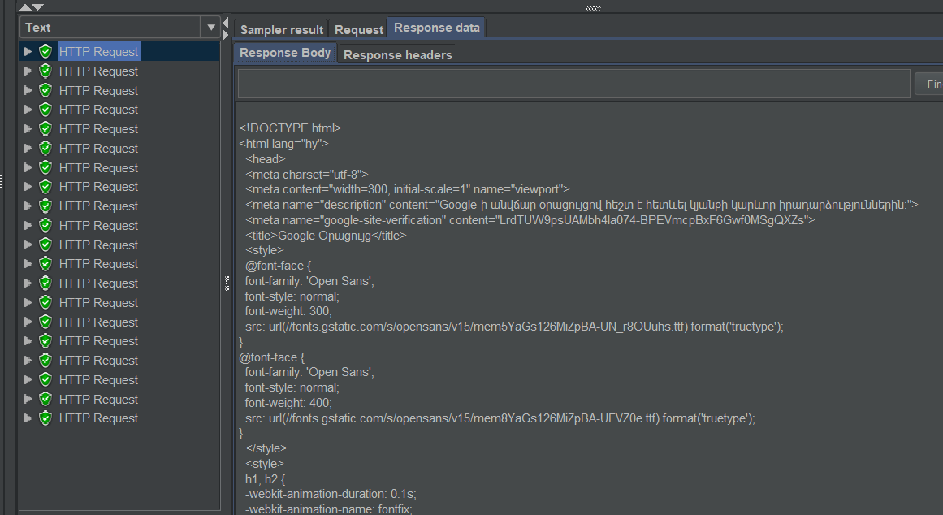
- Let’s check invalid case: Add slash after domain, or change path not existing one e.g. calend
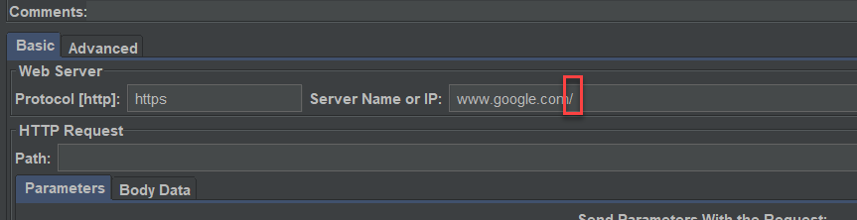
- Clear All, save and run
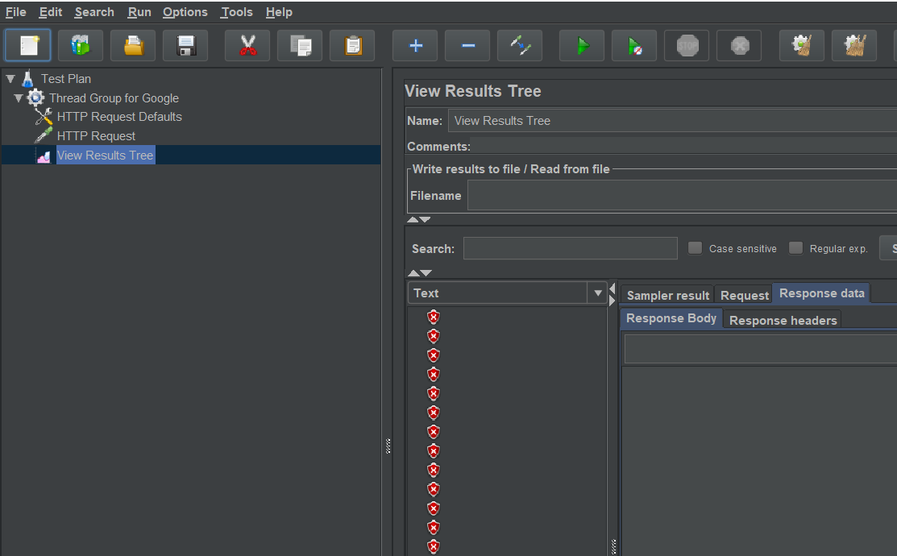
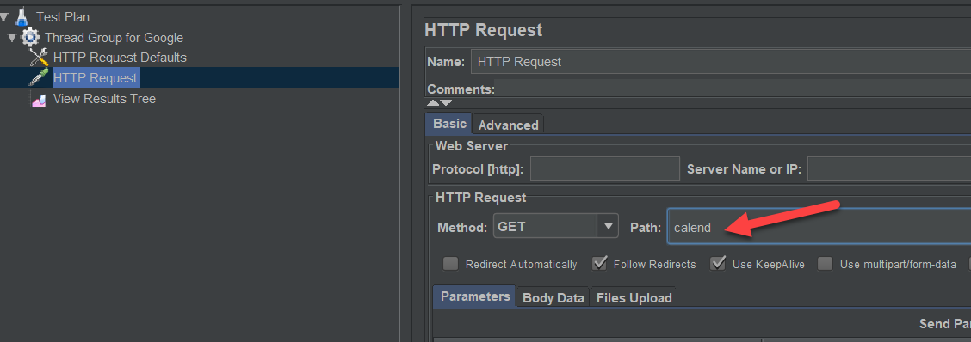
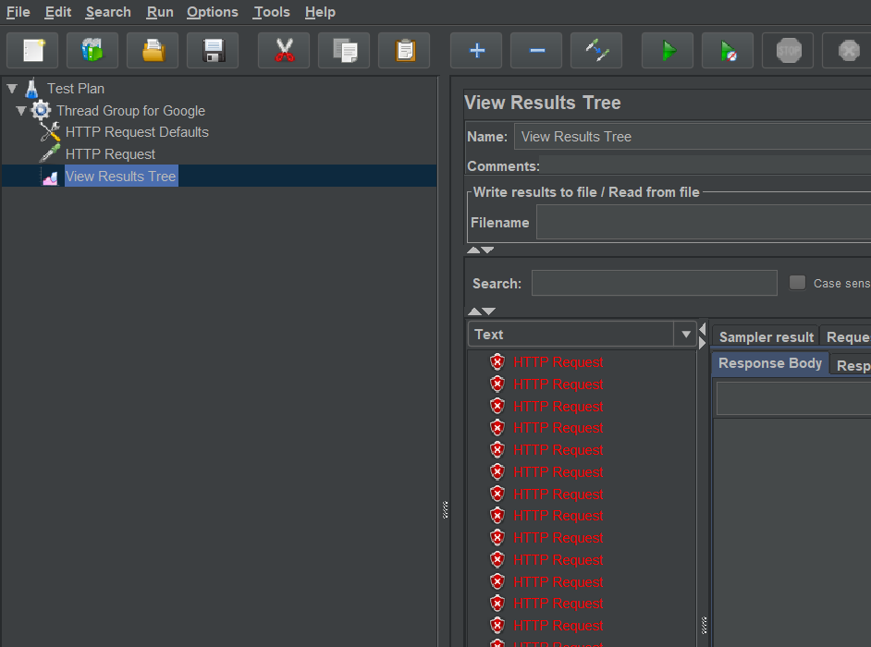
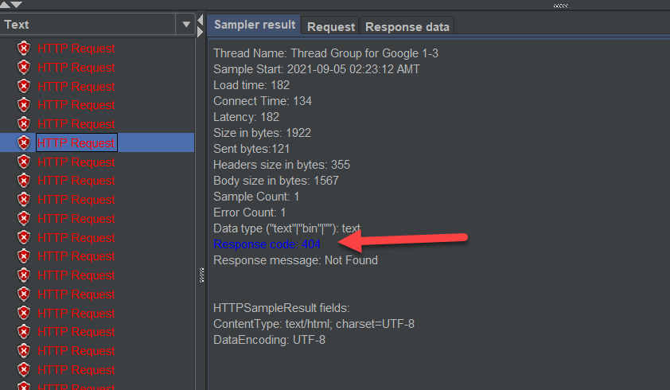
404 error -page not found
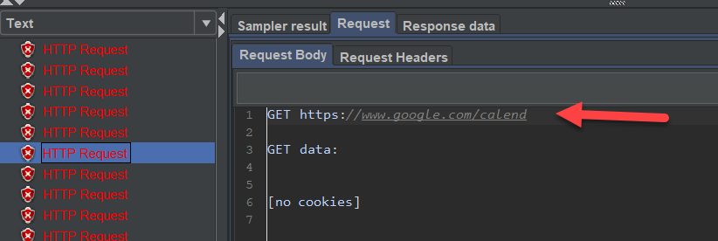
Exception is again 404.
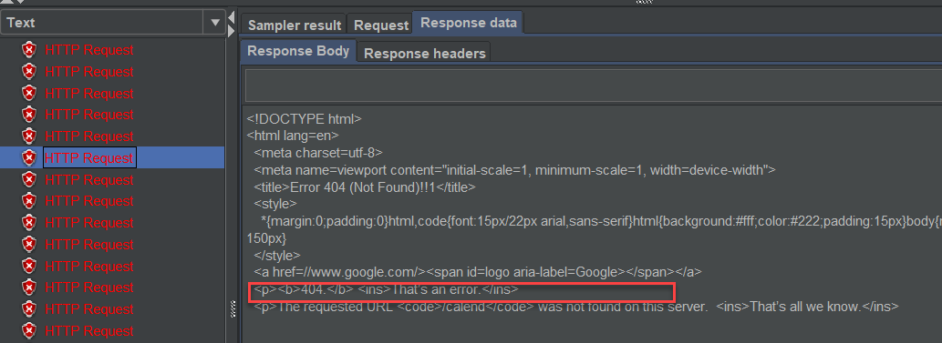
- Now correct changes back (calend to calendar)
- Change users, loops count , save and run
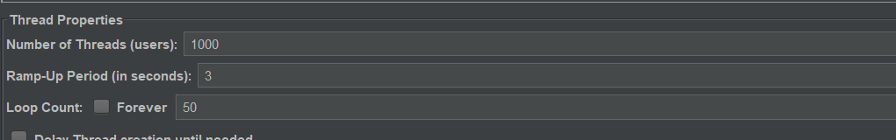
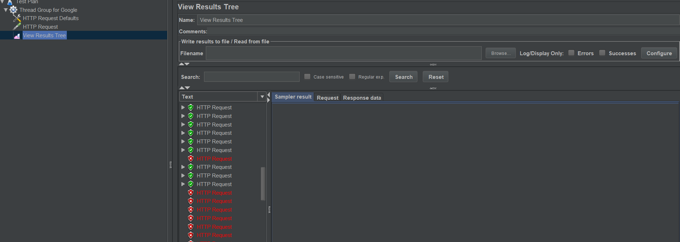
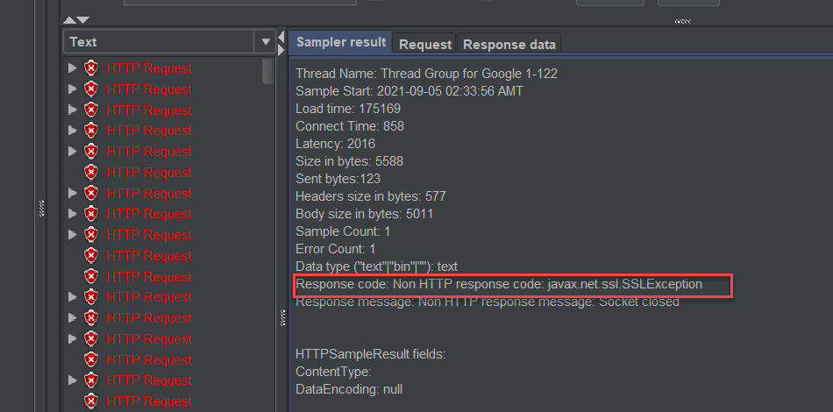
Request is correct
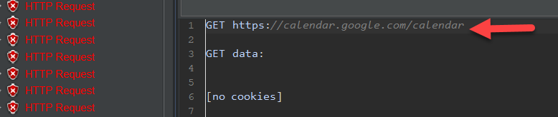
Exception
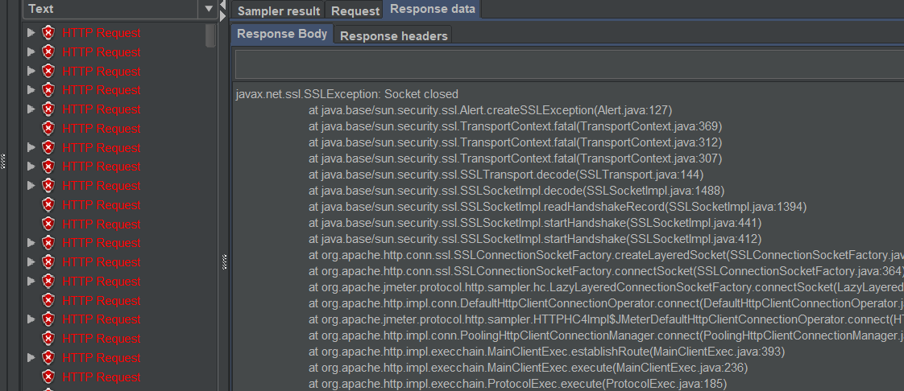

Summary Report
- To see the request error percentage, count of request add summary report:
Tread Group->Add->Listener-> Summary Report
- Save and run in summary Report page
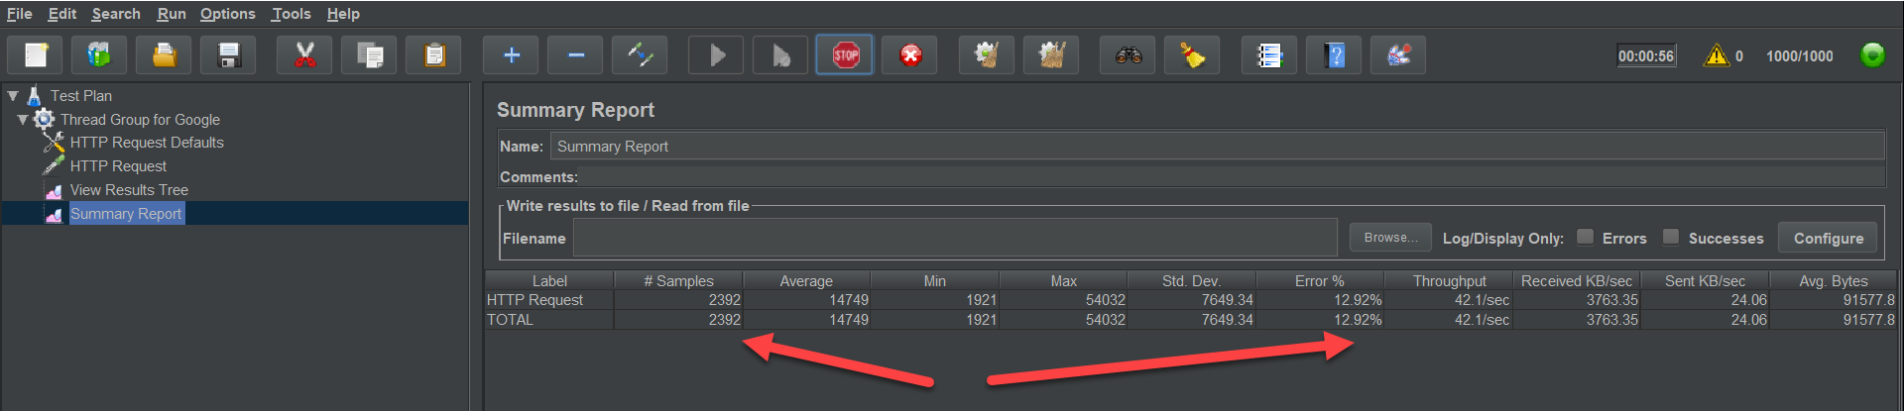

User Defined Variable
For example, we want to test https://reqres.in/api/users?page=2 – Get list Users
But then we will need to test the same URL for 3, 4,5 pages
In this case, we use User Defined Variable to replace the hardcoded values with variables. The URL will be universal, whatever you give will sit instead of the given variable.
- Add Variable in URL
Tread Group->Add -> Config Element -> User Defined Variables
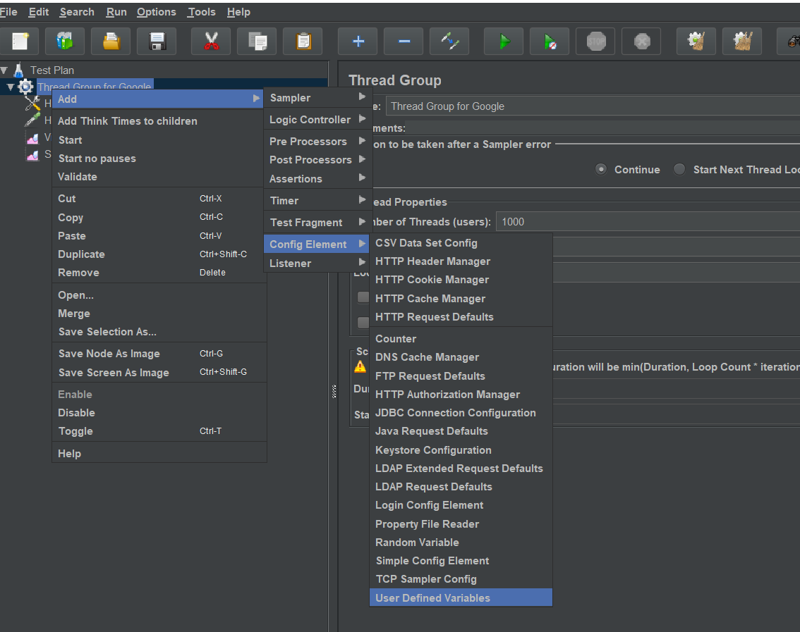
- As it is config move to above the HTTP Request Defaults
- Click add to add variable name and value
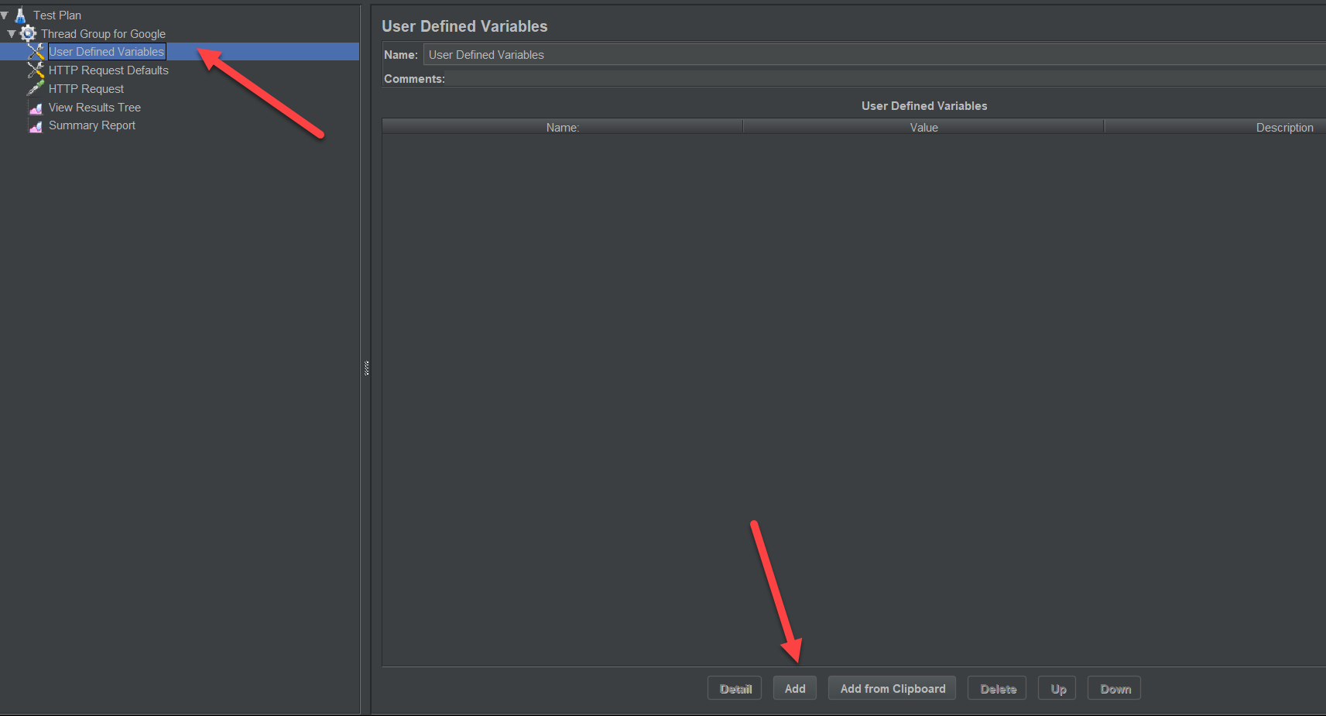
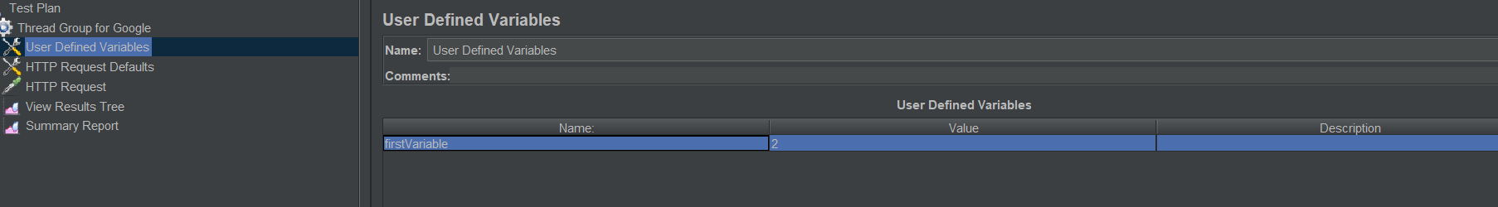
- Copy variable, navigate to HTTP Request page
- In path field after you value enter =${} and enter you copied variable name in the middle of {} like this
calendar=${ firstVariable}
